***Database Management System***

***CSL-220***

***Lab* # 1**

1. List all information of ‘Emp’ and ‘Dept’ tables.

**Output:**

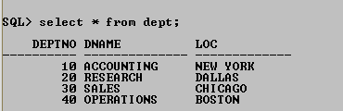

1. List the empno, ename, jobtitle and hiredate of employee from the employee table.

**Output:**

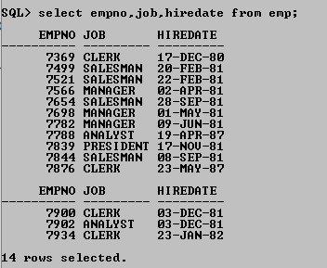

1. List name and annual salary of all the employees.

**Output:**

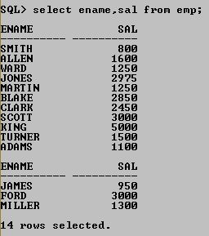

1. Increment the salary of each employee 10 times and then display the annual salary along with emp#, employee names and dept# from EMP table.

**Output:**

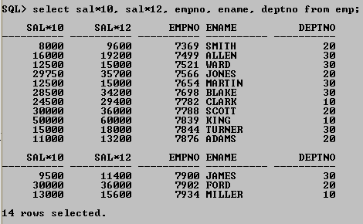

1. List the name,monthly salary and daily salary and hourly salary for employee; assume that there are 22 working days in a month,8 working hours in a day.

**Output:**

